

Islamic Azad University, South Tehran branch

Seminar report on machine vision

Master's degree in bioelectrical medical engineering

Title

Automation of Brain Tumor Identification using EfficientNet on Magnetic Resonance Images

Writer:

Narjes Firuzi

Spring 1403

Abstract

The general method for classifying brain tumors is through a biopsy, but a biopsy is only done after surgery in which a small piece of tissue is removed from the brain and examined under a microscope to determine whether it is a tumor. Due to the advancement of technology, especially in machine learning and artificial intelligence, it is possible for us to determine and classify the tumor without performing any surgery and to provide the available data from different MRI images to the device for classification. Through our work, we presented a technique for detecting tumors using EfficientNet, a pre-trained model using a transfer learning approach. This article focuses on three models from the EfficientNet family of models, namely 2EfficientNet-B, 3EfficientNet-B and 4EfficientNet-B. The proposed framework not only uses the pre-trained model to improve the training performance of a better model, but also uses thresholding to improve the dataset for better accuracy and data augmentation to increase the number of images in the dataset. The preliminary result shows that the EfficientNet family of models performs better than the previous CNN architectures because it uses the composite coefficient to scale all dimensions of depth, width and resolution of the image with a fixed ratio. The results also showed that by scaling the baseline architecture, the model is able to capture complex features and as a result the overall performance of the model is improved.

Keywords: transfer learning (TL); data augmentation; deep learning; Brain Tumor; Convolutional neural network

Chapter 1. Statement of the problem and the necessity of doing research

1-1 Preface

The use of machine learning in the field of biomedical sciences is quite efficient because machine learning can describe data better than biomedical models. It not only provides engineering solutions, but can be useful for advanced understanding. One of these is the use of machine learning in brain tumor diagnosis. Scientists are still working on a foolproof cure for cancer at any stage of severity, but early cancer detection may help prevent death. Tumors are of two types, benign and malignant. Benign tumors are non-cancerous and do not metastasize, meaning they do not have the ability to spread throughout the body. On the other hand, malignant tumors are cancerous, they can invade nearby tissues and spread throughout the body, forming other secondary tumors. Different imaging technologies are used to obtain the information needed for brain tumors, such as positron emission tomography (PET). PET), magnetic resonance imaging (MRI) and computed tomography (CT). Among all these technologies, MRI is the most widely used technique due to its beneficial properties. The use of 2D and 3D formats in MRI provides information about the shape, location, size and type of the brain. With the development of a computer-aided diagnosis (CAD) for automatic brain tumor detection, the workload of manual review of images, which is a confusing and time-consuming process, is significantly reduced. obtained from MRI is a challenging problem to overcome. Using the traditional method of machine learning (ML) techniques for classification, the features must be extracted manually, while CNN models can automatically extract the corresponding features, thus significantly improving the performance. they forgive However, acquiring a large amount of data to train a model based on deep learning is a challenge. To overcome this, this work presents a solution to use the concept of transfer learning to train a model on a large dataset and use that trained model with a dataset of brain images obtained from MRI to improve the accuracy and performance of the model. did In recent times, various works and researches have been carried out on brain tumor diagnosis using MRI to develop an automatic classification solution with high accuracy and performance. However, considering the contrast and texture changes of different shapes, it is still a challenge. By learning the deep representations for each pixel based on each of its methods (T1, T1c, T2, and Flair), it performed pixel classifications and then combined them to create a multimodal representation for each pixel, and the classification using It is carried out by CNN. The model achieves 67% accuracy. By using 1 CNN layer with 64 characteristic maps and 16 capsules of the original type, the accuracy of 86.56% was achieved. Saxena et al [16] suggested using pre-trained models including Vgg16, InceptionV3 and ResNet50. The highest accuracy of 95% was achieved with ResNet50 among all transfer learning methods used. Using CNN-LSTM, the highest accuracy of 84% was obtained with VggNet-LSTM by Shahzadi et al. . Using Singular Value Decomposition (SVD) for 18 classification, the accuracy of 96.66% was achieved. However, the dataset used by them only had 20 normal and 50 abnormal data. Mohsen et al. [19] proposed to combine Discrete Wavelet Transform (DWT), which is a powerful tool for feature extraction and Principal Component Analysis (PCA), with a deep neural network classifier with an accuracy of 93.94%. They suggested that a model improved to be used to diagnose brain tumors. They designed this improved model using ResNet-50 as the base model, from which the last 5 layers were removed and 10 new layers were added, and the number of layers was increased from 177 to 182. Additional layers added were Relu, BatchNormalization, Dropout respectively. , fully connected, Relu, Max pooling, fully connected, classification and softmax layers. In this system, they achieved a maximum accuracy of 97.01%.1

1-2 statement of the problem

A brain tumor is an abnormal mass in the brain that can be benign or malignant depending on the nature of the constituent cells. The origin of the tumor may be from the brain tissue, or it may spread to the brain from another place, or it may metastasize. A brain tumor, in other words, is a hard and dense intracranial neoplasm, or a tumor of abnormal cell growth, inside the brain or central spinal canal.

Brain tumors include all intracranial tumors or tumors in the central spinal canal. These tumors arise through uncontrolled and abnormal cell division, and are usually either in the brain itself (including: neurons, glial cells (astrocytes, oligodendrocytes, ependymal cells, Schwann myelin-producing cells), lymphatic tissue, blood vessels). blood), or in cranial nerves, meninges, skull, pituitary gland and pineal gland. Also, these tumors can be the result of the spread of malignancies that have primarily involved other organs, in which case it is called a metastatic or metastatic tumor.

Although any brain tumor is inherently serious and life-threatening due to its aggressive and spreading nature in the limited space of the skull, brain tumors (even their malignant types) are not always fatal. Brain tumors or intracranial tumors can be cancerous (malignant) or non-cancerous (benign); However, the definition of a malignant or benign neoplasm in the brain is different from the definitions that are commonly used in other types of cancerous or non-cancerous tumors involving other parts of the body.

The degree of threat of a tumor depends on a combination of various factors, such as: type of tumor, location and size of the tumor, and how it spreads and develops. Since the brain is completely covered by the skull, rapid and early diagnosis of brain tumor is only possible if paraclinical tools and appropriate diagnostic tools that define the condition of the intracranial cavity are available and quickly be employed But usually, the diagnosis of brain tumor occurs in the advanced stages of the disease and when the presence of the tumor has caused unexplained symptoms and signs in the patient.

The importance and necessity of conducting research

Brain cancer is still something that doctors and scientists are fighting. Of course, it is also true that with special treatments, the lifespan of brain cancer patients increases. However, it is closer to the truth that all treatments try to make a person's life easier by eliminating the symptoms. In some cases, the treatment can lead to something unexpected, but it is better to try the remedies.

• Chemotherapy and surgery are the most common treatment options. In cases of benign brain tumors, surgery may be completely successful. There are many people who were treated after the operation and were able to return to their normal lives.

• Today's medical techniques are so advanced that stereotaxic surgery can be performed without breaking the skull. In addition, new treatment methods have fewer side effects and guarantee a better chance for good results.

• There are also vaccines being tested that may be successful in increasing the life expectancy of brain tumor patients.

As shown in Figure 1-1,...

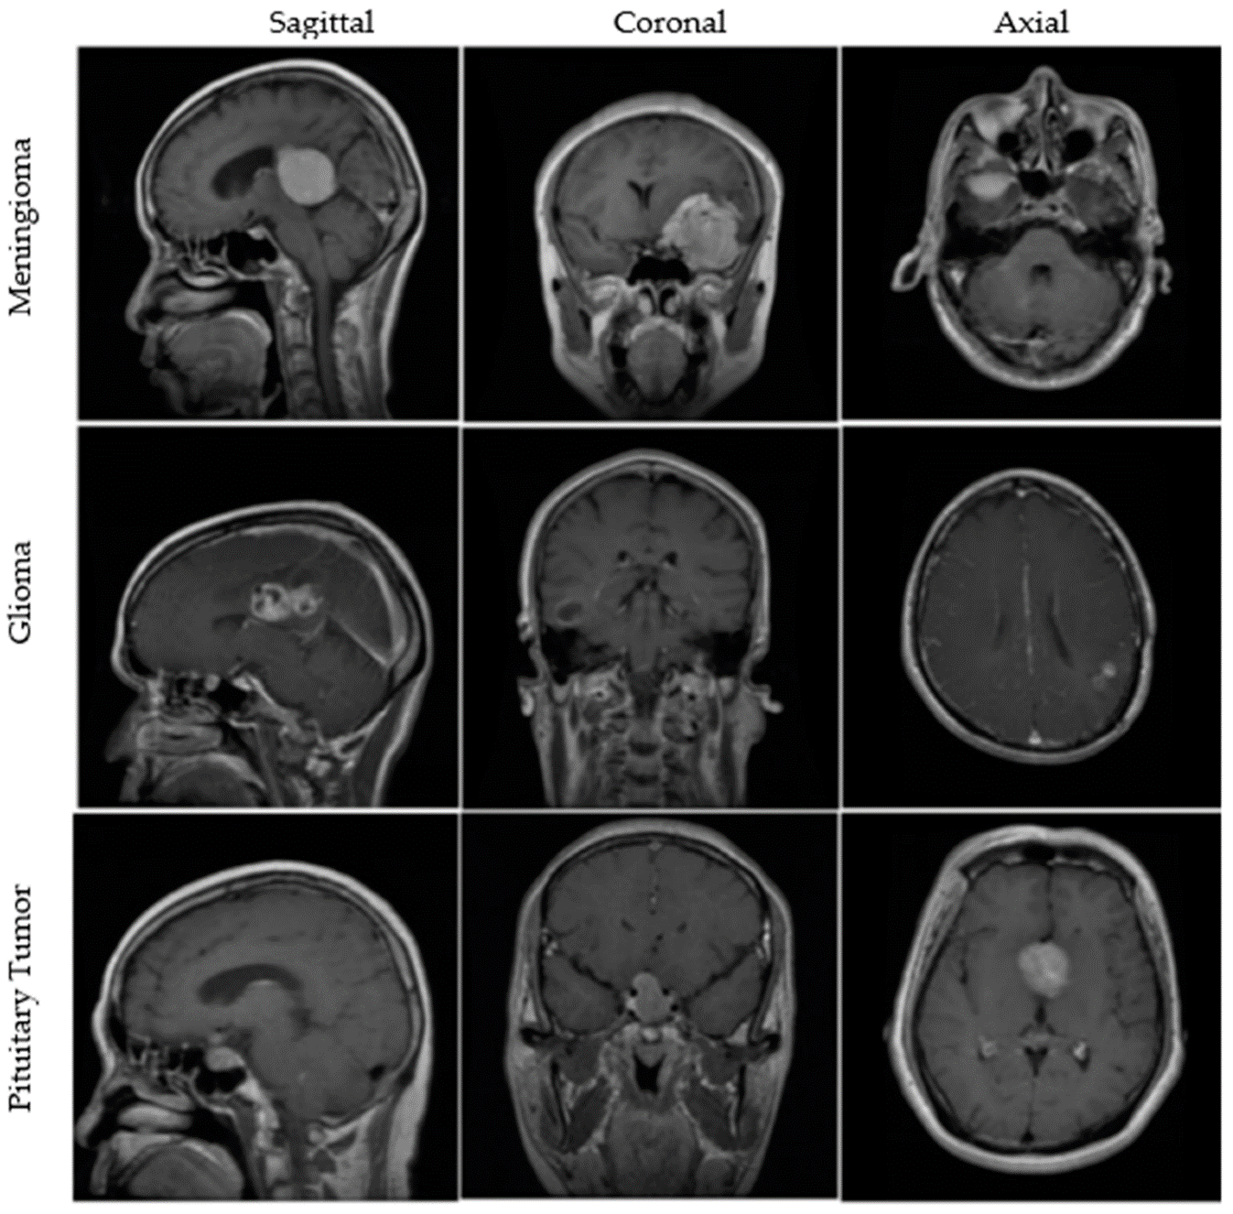

Figure 1 - 1. View of tumors in MRI.

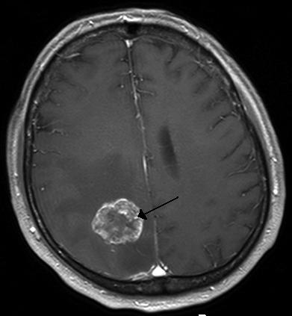

Figure 1-2. The shape of the tumor and its location.

The proposed method in the first article

2. Materials and methods

This study was done to detect the presence of brain tumor. Picture. 1. It shows the proposed framework. In the first step, images were pre-processed to remove irrelevant parts from each image and then images were added to increase the number of images in the dataset. In the second step, the pre-processed MRI data set was used to train the obtained model using the pre-trained model weights. In the third stage of the experiment, the images were classified into two groups: images with tumor and images without tumor.

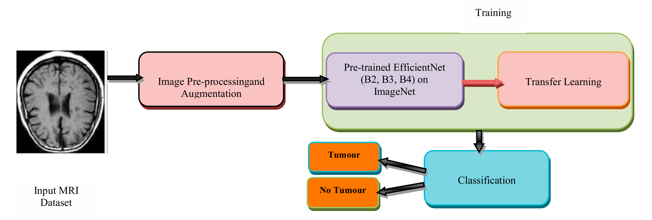

Figure 1-2: Workflow of the proposed framework

2.1. Image dataset and image preprocessing

The image dataset used in this proposed method was the 2020 Brain Tumor Diagnosis dataset collected from Kaggle. Out of 3000 images in the dataset, the number of images containing tumor is 1500 and the remaining number of images without tumor is 1500. Therefore, this dataset consists of normal class and tumor class. The images in the dataset contained many undesirable spaces and corners, which required poor classification. First of all, it is necessary to crop the unwanted areas and keep only the relevant parts of the image. Images were cropped by finding the extreme points in the lines. After loading the original dataset, the magnetic resonance (MR) images are converted to grayscale and slightly blurred, and then the MR images are converted to binary images using thresholding. Thresholding makes it possible to separate the brain area from the rest of the space. Then the largest contour from the thresholded images was found, which we assume is the brain region. Then we find the four extreme points (extreme right, extreme left, extreme upper, extreme lower) as seen in Figure 2. Hence, we finally crop the images using the extreme points and contour information. Different MR images in the dataset have different sizes, heights and widths. We have used data augmentation to increase the number of images since the data set used is not very large. In data augmentation, random transformations are performed and different copies of the same original image are created but with different scaling, orientation, etc. As the dataset increases, the accuracy of the classification model improves. In the data augmentation performed by us, we have used 8 enhancement strategies which are rotation, horizontal shift, vertical shift, scaling, cropping, brightness and horizontal and vertical rotation. The dataset was divided into three sets, in which 2000 images were used for the training sample, 600 images for the validation sample, and 400 images for the test sample. The size of the images was changed to (180x180) pixels.

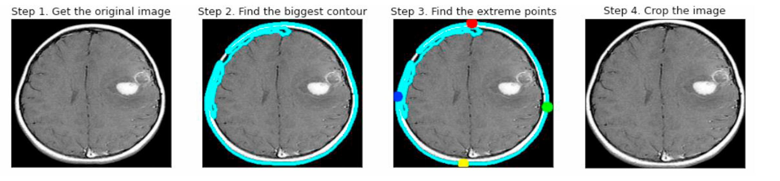

Figure 2-2: Finding extreme lines using thresholding and cropping images

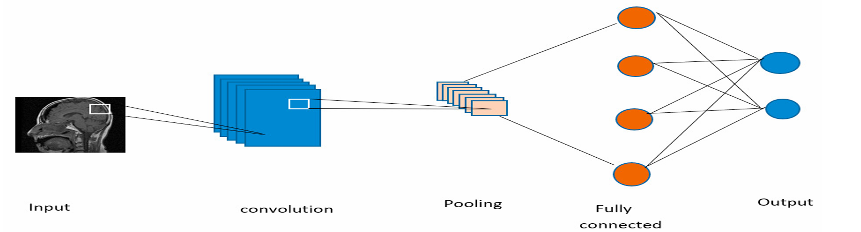

Figure 3-2: CNN convolutional neural network architecture

2.2. Convolutional neural network

CNN is a class of neural networks in deep learning that takes input images and assigns biases and weights to different objects in the image to classify them among each other. CNN transforms an image into a form that is easier to process, without compromising the relevant and salient features required for an accurate prediction. The CNN architecture can be seen in Figure 3. The three main components of CNN are:

• A convolutional layer extracts low-level and high-level features. The first convolutional layer is now supervised to draw low-level features, and as we add more convolutional layers, the architecture can extract high-level features as well.

• An integration layer is added to reduce the computational power for running the data using dimensionality reduction, where the spatial size of the extracted feature is reduced.

### • After applying the convolutional layer and pooling, the model is successfully trained to understand the features. The final output is smoothed and fed to a fully connected (FC) layer to classify the images into different classes.

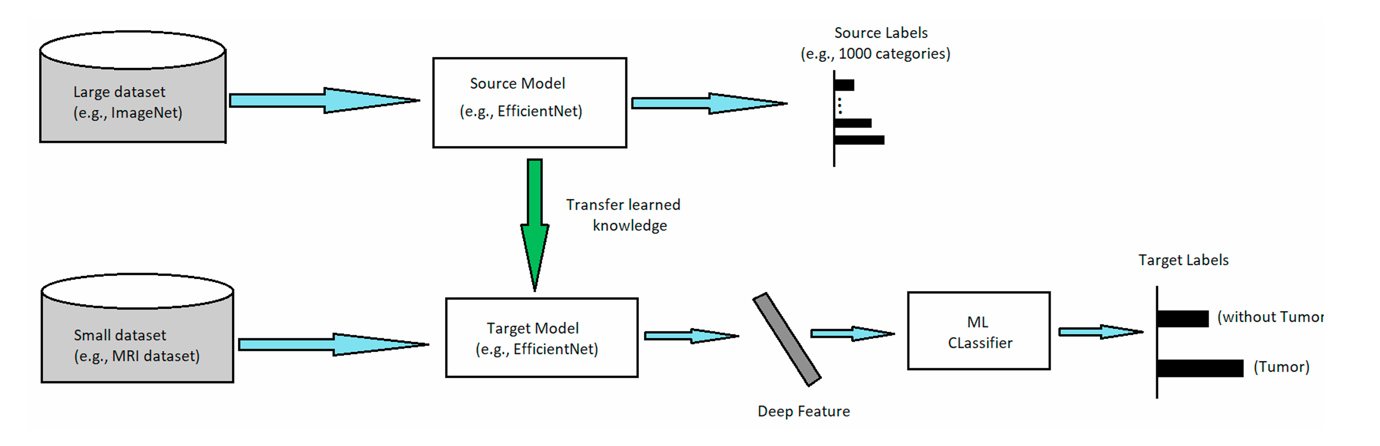

Figure 4-2: The concept of transfer learning

### 2.3. Transitional training

### In general, given a very large data set it can be found that the performance of CNN is better compared to a small data set. Ideally, it is not always possible to train a model with a huge amount of data, the concept of transfer learning is used in such cases as shown in Figure 4. In transfer learning, a model is pre-trained on a large standard dataset (such as Image-Net [21]), which can then be used as a feature extractor for a relatively smaller dataset, such as a dataset of MR images. to be In recent years, transfer learning has been widely used in various fields such as X-ray baggage security screening, lung pattern analysis, etc. This improves efficiency and provides a more general approach to using different algorithms to solve new challenges.

### 2.4. EfficientNet architecture

### A variety of pre-trained models such as 16VGG-, 50ResNet and 3Inception V have been used in several fields for image classification. In 2019, a CNN architecture called EfficientNet was introduced, which uses hybrid coefficients for efficient scaling. The dimensional architecture increases the width, resolution, and depth of available resources in a fixed ratio without compromising model performance. Using the MNAS AutoML framework for neural architecture search, a new base network is developed, which is dependent on a hybrid scaling method that improves both accuracy and efficiency (FLOPS). This architecture uses Mobile Reverse Bottleneck Convolution (MBConv). By continuously using the compound scaling technique to increase the scale of the base family of models, 1EfficientNet-B to 7EfficientNet-B were obtained. In this paper, we have used 2EfficientNet-B, 3EfficientNet-B and 4EfficientNet-B to detect brain tumor using MR images dataset. After image preprocessing and enhancement, 2EfficientNet-B, 3EfficientNet-B and 4EfficientNet-B weights were pre-trained in the Image-Net database to be used for better model training. We added a global max-pooling layer followed by a dropout operation with a rate of 0.2 to avoid overfitting. Sigmoid was used as the activation function that applies a non-linear transformation to the input.

Methodology in the main article

In this paper, the proposed framework for tumor classification from T1w MRI images using MLT. A fully annotated MRI image database of size 256x256 was obtained from BRATS Brain Tumor Segmentation and Harvard University datasets for evaluation. This work was performed using MATLAB 2020 with Core™ i7 2.5 GHz. Three modules make up the proposed technique. The system framework is divided into four main parts. The manual code of the skull removal method in the first module is used to remove the unwanted parts of the brain tumor images and remove their noise using the median filter while preserving the edge information. In the next step, the removed images were segmented using the C-V active contour technique to obtain the separated areas in the MRI images. Finally, in the next module, the basic features were extracted based on GLCM and the basic features were selected using different statistical parameters.

The last module is a classifier, which is necessary to classify the tumor region regardless of the normal brain image by considering KNN and SVM classifiers. The Fove diagram considered for brain tumor detection and classification from the selected MRI image is shown in Figure 1. The proposed work is intended for accurate tumor segmentation without losing tumor details and effective tumor classification whether tumor or non-tumor. The proposed system according to the algorithm presented above (Algorithm 1) is presented step by step and the details of the key elements are briefly presented in the sub-sections.

Preprocessing Tumor preprocessing

It is necessary because it improves some features of the image that are essential for future processing. The skull does not have any information about the tumor that can be physically removed or removed by the different skull removal methods of the Brain Extraction Tool-BET to save processing of the unwanted area. Then, the noise in the brain MRI images is removed using a median filter. The median filter is a non-linear filter that reduces noise from level two while preserving tumor edge information. Consequently, we recommend the median filter for noise removal after skull stripping in our study over others.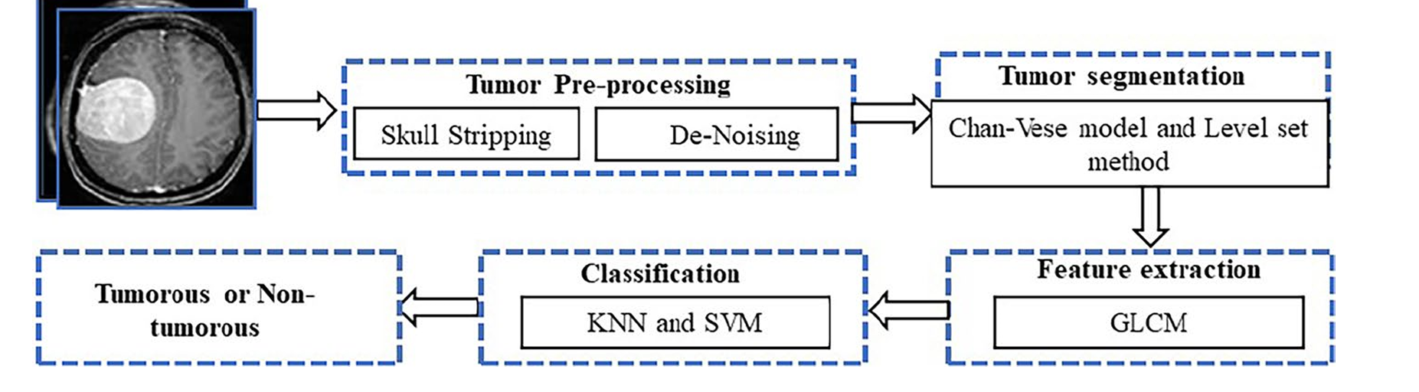

Figure 5-2: Suggested flow diagram of brain tumor classification and classificationTumor

classification

Image segmentation divides a digital image in computer vision into segments (collections of pixels, also known as image objects). The purpose of segmentation is to make the image representation more meaningful and easier to review by simplifying and/or changing it. Image segmentation is often used to determine objects and boundaries in images (lines, curves, etc.). Image segmentation, specifically, is a way of assigning a label to each pixel in an image so that pixels with the same label have comparable features. It is shown to be very efficient in packaging a wide range of images, including those that are challenging using current segmentation techniques. Threshold values ​​and gradient-based algorithms are common approaches. Segmentation is used to obtain tumor information from a pre-processed test image. In this work, we use a semi-automated CVS technique to extract the tumor part. CVS starts with a bounding box and the box can converge towards the tumor region. This convergence identifies all possible similar pixel groups of the tumor segment and CVS stops its confusion when the energy function of the CVS model reaches a minimum value. Surface set partitioning (LSS) method: The surface set method is often used for summarizing user interface generation, mainly when topological changes occur. Over the past few decades, the LSS method has been used for image segmentation. Surfaces or lines are a set of functions with higher dimensions at zero levels, which are called surface set functions. It can be used to represent surfaces or lines with complex topologies and inherently change their topological shape. The partitioning problem has been solved using partial differential equations and Hamilton-Jacob's method. Figure I, which can be modeled as in Eq. (1), is used to deal with the power of heterogeneity.

Feature extraction

When the input data is very large, its information may be redundant, so reduce to the required data extracted by transforming the high-dimensional data into a feature vector set. This module extracts the critical elements that are necessary for image classification. Texture features are generated from the segmented image that represents the texture feature of the image, a segmented brain MR image. Since GLCM is a robust and high-performance method, it is used to extract these features. The GLCM texture feature extraction method is very competitive because using a smaller number of gray levels reduces the size of the GLCM, reduces the computational cost of the algorithm, and maintains high classification rates at the same time. Abnormally, these GLCM properties are used. Texture contains important information about surface structure. Texture features based on spatial relationships with gray color can be used for classification.

Tissue feature images are generally used in medical imaging to investigate lesions or tumors, as they are considered a surface feature of the tumor. Each tumor has its own representation in statistical tissue. Two methods are used to calculate texture properties: structural and statistical. Second-order statistical features are extracted using the given method. Contrast, correlation, uniformity and homogeneity are the four texture features that are extracted. One of the main reasons for choosing only four features is to select the most reliable data. The proposed method extracts geometric features, also known as shape features, from the entire dataset. The purpose of extracting geometric features in this study is to determine the characteristics of the shape of the tumor area. As a result, 9 geometric features including area, wide area, circle, perimeter, direction, extension, strength, length of major axis and length of minor axis are recovered. Then, for each image, these parameters are calculated one by one from the segmented tumor regions. The main purpose of extracting these features is to collect tumor geometry information, which is then integrated into tissue features to improve classification accuracy. Later, a two-tailed t-test feature selection technique is used to select the leading features based on the p-value obtained during the statistical test. Feature selection fur helps reduce complexity during classifier training and testing and helps achieve better classification accuracy.

Classification

Various classifications are considered such as simple bayes, logistic regression, random forest, decision tree etc. Logistic regression is only a binary predicted variable and the simple Bayes estimator is fast but bad. The decision tree is unstable due to slight changes in the data. Random forest is complex and difficult, but it reduces the problem too much. Based on the literature, KNN and SVM provide promising results. Therefore, in the proposed work, we preferred KNN and SVM for classification purpose. Bi- or multi-level classifiers play an important role in MLT, and several previous works confirm the need for classifiers. The accuracy depends on the feature extraction measures employed to extract essential features from MRI and the feature selection method adopted to identify dominant features.

• SVM is used to train and classify input features. There are also other variants of the SVM family, including kernels, bounding boxes, and autoscaling. The kernel functions were chosen because of their widespread use. They include polynomial, linear, and Gaussian radial-based GRB functions. SVM parameters used in the model are RBF kernel, C-regularization parameter and C=10 in the model. Gamma is a kernel coefficient used in RBF kernel gamma, which is considered here as 1/n features.

KNNFeature Similarity: Used to predict the values ​​of new data points, which indicates that a new data point is assigned a value based on its similarity to problems in the training set. Because it stores all the training data, it is a computationally expensive unified algorithm. Compared to other supervised learning methods, this method requires a lot of memory capacity. If N is too large, prediction is slow. Moreover, it is sensitive to data scale and irrelevant factors (Kotswara et al., 2019; Vamsidar et al., 2019). There is no organized technique for finding the best motivation for "K". We have to cover different qualities by experimenting and expecting vague preparation information. Choosing simpler features for K can be tragic and affect the outcome. More important estimates of K will have smoother selection constraints, which means lower volatility, however, is prone to spread and is also computationally expensive. Another approach to choosing K, however, is cross-validation. An approach to select cross-validation datasets from preparatory datasets. Take a small portion of the training data set and treat it as a validation data set, and then use its equivalent to evaluate different potential estimates of K. In this way, we predict the sign for each event in the validation set using plots K equal to 1, K equal to 2, K equal to 3, and then see which estimate of K gives the best performance in the validation set. gives us And then, we can take that value and use that as our last set of calculations, so we limit the validation error. When all is said and done, the choice of estimator k will be k=sqrt(N), where N is the number of trials in your training dataset.

Results of the first article

Test analysis

Three sets of experiments were performed for brain tumor detection using MR images dataset. In each set, three different EfficientNet models were used to classify the presence of tumors. One of the most important criteria used to evaluate the performance of a model is the confusion matrix.

The confusion matrix is ​​evaluated using four performance measures: true negative (TN), false positive (FP), false negative (FN), true positive (TP). TN now represents the number of tumor-free MR images that are correctly classified as tumor-free. FP indicates the number of tumor-free MR images that were misclassified as having tumor. TP reflects the number of tumor-presence MR images that are correctly classified as having a tumor. FN reflects the number of MR images with the presence of tumor that are incorrectly classified as tumor-free. Accuracy: Gives us the fraction of predictions that our model was correct. This is the ratio of the number of accurate predictions to the total number of predictions.

Accuracy = (TP + TN) / (TP + TN + FP + FN)

Sensitivity (recall): is the proportion of true positives that are correctly predicted as positive. Sensitivity/Recall = TP / (TP + FN)

Accuracy: Returns the fraction of positives that are correctly identified out of all predicted positives.

Accuracy = TP / (TP + FP)

F1 score: Harmonic average is the precision and recall of the model. It considers both precision and recall for calculations.

F1 score = 2 * precision * recall) / (precision + recall)

Feature: is the proportion of true negatives that are correctly predicted as negatives. Feature = TN / (TN + FP)

In the first set of experiments, the weights of the pre-trained system 2EffecientNet-B were used. By training the network with the system, the accuracy and loss curves obtained are shown in Figure 5. As shown in the figure, the training accuracy of the system is ~99%. The accuracy obtained in the validation set was 98.75% while the accuracy obtained in the test set was 100%. 2EfficientNet-B performance metrics.

Now, in the second stage of the experiment, the weight of the pre-trained EffecientNet-B3 model was used. By training the network with the model, the accuracy and loss curves obtained are shown in Figure 7. As can be seen from the figure. The training accuracy of the model is ~99%. The accuracy achieved in the validation set was 98.33% while the accuracy achieved in the test set was ~99%. 3EfficientNet-B performance metrics

In the third set of experiments, the weight of the pre-trained EffecientNet-B4 system was used. By training the network with the model, the accuracy and loss curves obtained are shown in Figure 9. As shown in Figure 9, the training accuracy of the model is ~99%. The accuracy obtained in the validation set was 99% while the accuracy obtained in the test set was 99.5%. Performance measures of 3EfficientNet-B The experimental results strongly suggest that the 2EfficientNet-B method can be more effective and can significantly improve the overall recognition of the computer-aided diagnosis (CAD) system, especially for MRI brain images. Compared to other deep learning approaches, the performance measures of the 2EfficientNet-B technique achieve more accuracy.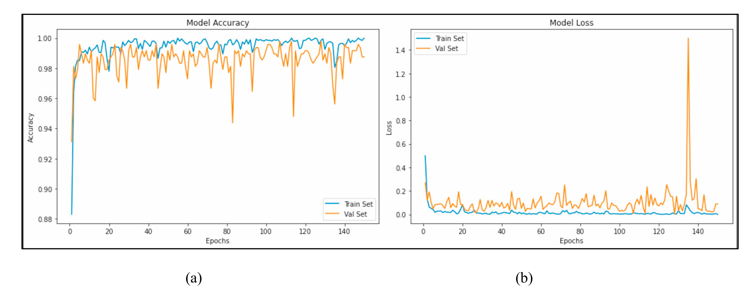 Figure 1-3: (a) Training and validation accuracy curves. (b) Training and validation loss curves for 2EfficientNet-B

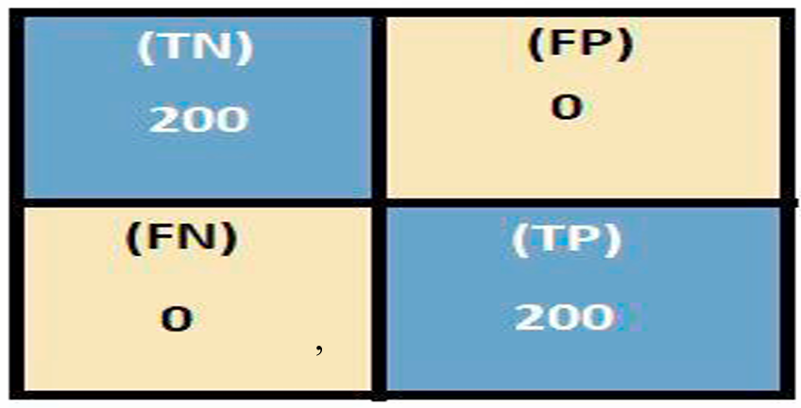

Figure 2-3: Confusion matrix for 2EfficientNet-B

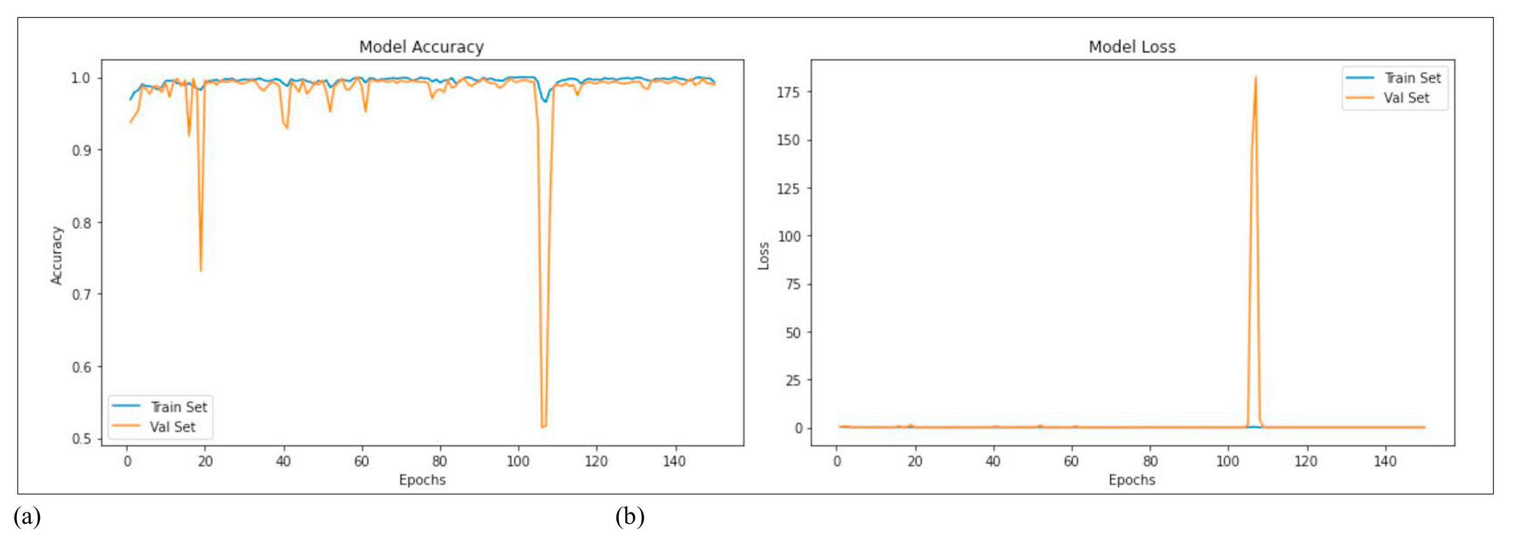

Figure 3-3: Training and validation accuracy curves (b) Training and validation loss curves for EfficientNet-B3

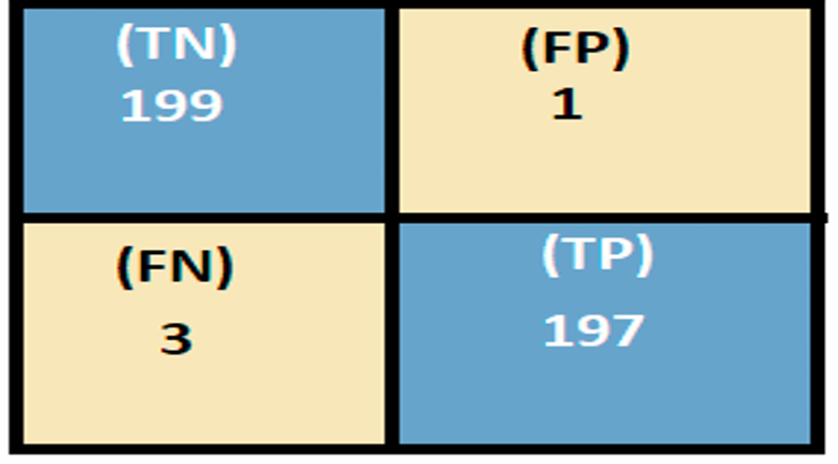

Figure 4-3: Confusion matrix for EfficientNet-B3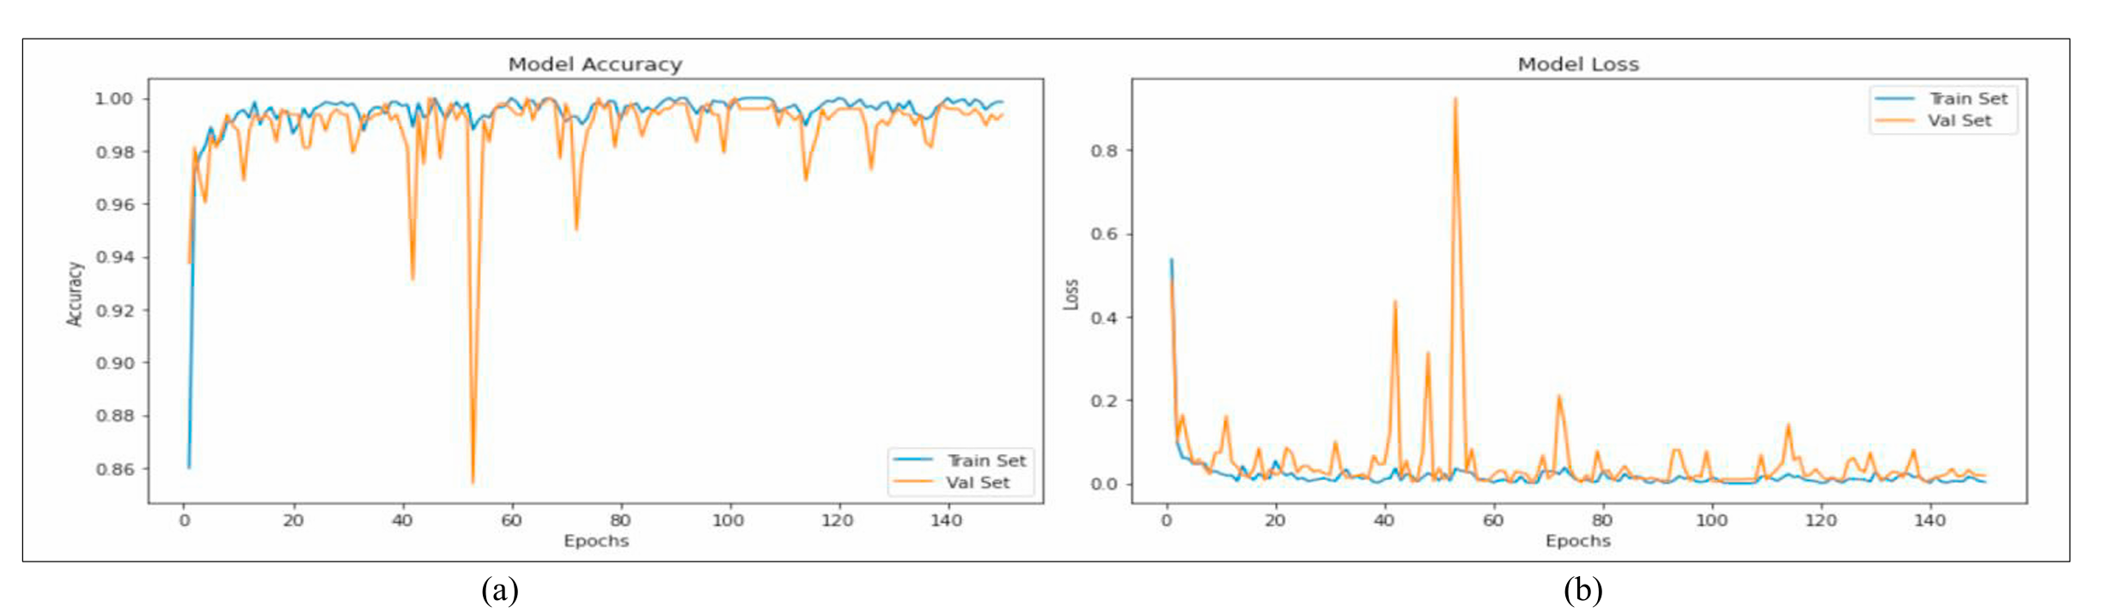

Figure 5-3: (a) Training and validation accuracy curves. (b) Training and validation loss curves for EfficientNet-B4

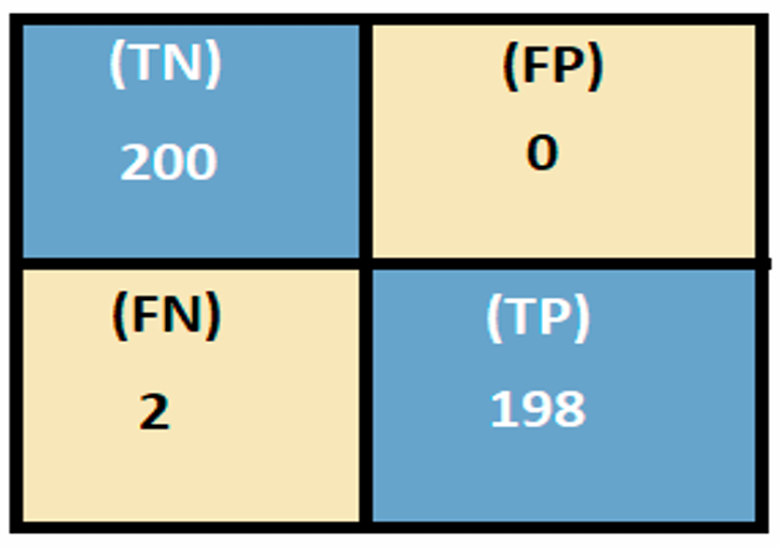

Figure 6-3: Confusion matrix for EfficientNet-B

Results of the main article

Results and discussion

In this section, the results are described in terms of performance measures. We have selected some malignant (cancerous) and benign (non-cancerous) tumors from this dataset for segmentation and classification. The proposed work is validated on two datasets, including BRATS 2017 dataset and Harvard Medical Images. T1-weighted MR brain images in the axial plane with a resolution of 1 mm3 make up the BRATS 2017 dataset. It has a slice thickness of 1 mm, 3% noise (estimated due to bright tissue), and 20% intensity non-uniformity in T1 (RF) mode. This dataset (dataset-66) has 152 photos with a size of 256x256 pixels. Sample and pre-processed images of the selected dataset are shown in Figure 2. The results of both CVS model and LSS method are compared in terms of similarity index criteria. In addition, the GLCM features of the binary segmented image are investigated. Both KNN and SVM classification methods are used to evaluate the framework. The performance of these methods is evaluated by four criteria: accuracy, specificity, sensitivity and accuracy. The evaluations are divided into two parts. First, the segmentation findings are analyzed in terms of Jaccard Similarity Index (JSI), Dice Coefficient (DC), and Structural Similarity Index Measure (SSIM). The area and number of pixels are found in the first phase. Classification results are then generated in a second step, with SVM as the leading classifier, and its performance is compared with k-nearest neighbors (KNN). Accuracy, specificity, sensitivity, precision, false negative rate (FNR), false positive rate (FPR), negative predictive value (NPV), and positive predictive value (PPV) of these classification algorithms are all measured.

Segmentation results

This section analyzes the segmentation results and checks the accuracy of active contour models (ACM), such as the CVS model and the LSS method. Three parameters including JSI, DC and SSIM are calculated to check the performance. The performance evaluation criteria are briefly described below: Dice coefficient: “The Dice coefficient is used to find the degree of similarity between the extracted tumor and the manually or expertly segmented tumor.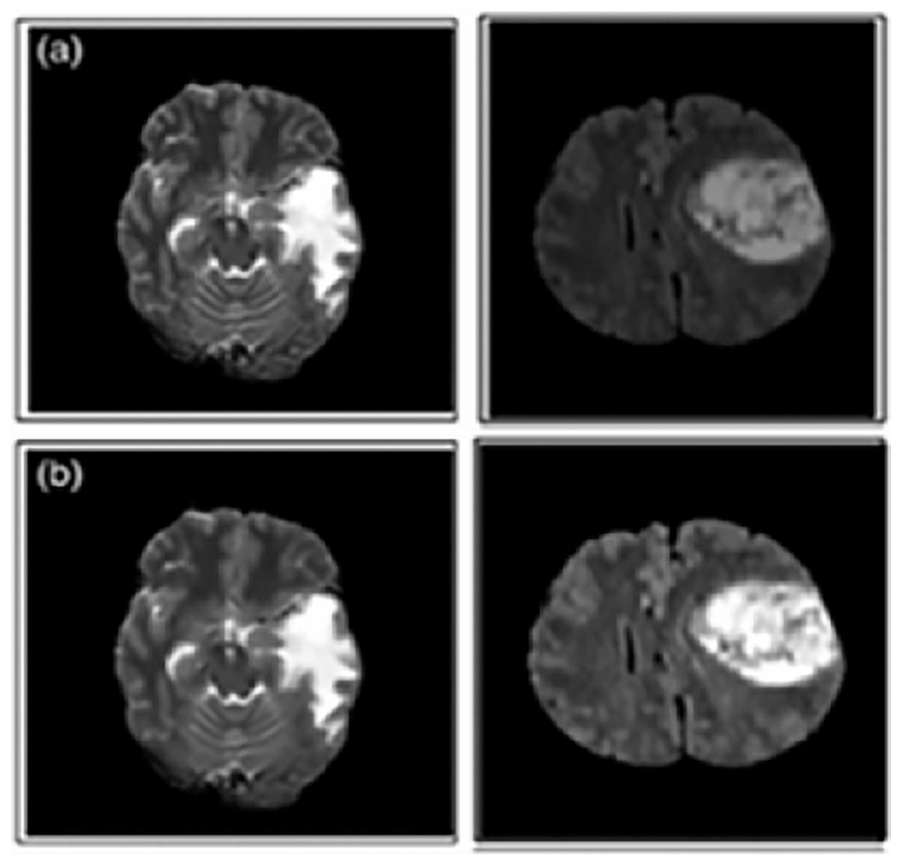

Figure 7-3: Samples and pre-processed images (a) original images without skull and images without noise in the row below (b)

Figure: Sample and pre-processed images (a) Original images of the skull and the row below (b) Removed images

1 → X and Y overlap. 0 → X and Y do not overlap. Structural Similarity Index Measure (SSIM): This represents the deterioration of image quality due to data compression, and the term given in Eq. (3), as shown below.

where μ is the mean, σ is the variance, and σ is the covariance. c are constant. A higher SSIM value is required for good contrast and brightness. Jaccard similarity index: calculates the degree of similarity between two pieces of data where X and Y denote the identified region and the original region. Higher values ​​indicate better performance. Compared to the LSS method, the C-V model is based on the Mumford-Shah partition function and energy minimization, which is used to solve the problem easily. C-V model is efficient in contour detection. The segmented output images along with selected images from BRATS 2017 are shown in Figure 3. According to Figure 3, the CVS method divides the tumor part from the pre-processed images accurately with appropriate information compared to the LSS method. The LSS method requires human interaction and it is difficult to determine the initial location of the tumor. The CVS method is universally accepted for the segmentation of hemispheric brain tumors. 20 brain tumor photos are selected from both data sets. The segmentation results were obtained. The size or volume of the tumor depends on its benignity (5 cm), but in this work we choose abnormal images whose size does not matter, so the proposed work can separate any size of tumor from MRI images. Their ground truth images calculate the selected parameters. An expert doctor designs the ground truth images of the Harvard dataset and the ground truth images of the BRATS 2017 dataset are available with the same download page. The performance of CVS and LSS is evaluated by analyzing between the segmented tumor and the ground truth. For this purpose, we apply it to two high-quality images from both datasets and register them accordingly.

Here, only the similarity with the ground truth image is measured instead of other parameters. JSI, DC and SSIM values ​​are calculated and recorded in the table for ACM models in both datasets, respectively. A bar graph is plotted for the JSI values ​​obtained by LSS and ACS in the selected data set, shown in Fig. Segmentation results criteria for the BRATS 2017 dataset, which has an average JSI of 0.9068 for the LSS method and 0.9477 for the CVS model, respectively. Following that, using ground truth images, similar parameters were estimated for the Harvard dataset, yielding average JSI values ​​of 0.8768 for the LSS technique and 0.9205 for the CVS model, respectively. Finally, in the same way, DC and SSIM values ​​are calculated for both datasets. From all performance measures, it can be seen that the proposed CVS model performs better on the BRATS 2017 dataset compared to the Harvard dataset. In addition, a comparison was made for the BRATS 2017 dataset with existing methods for average JSI values. The CVS model in the proposed framework shows an average of 94.77% of JSI compared to existing methods. The highest JSIs obtained only with existing techniques are 88.90 and 94.00%.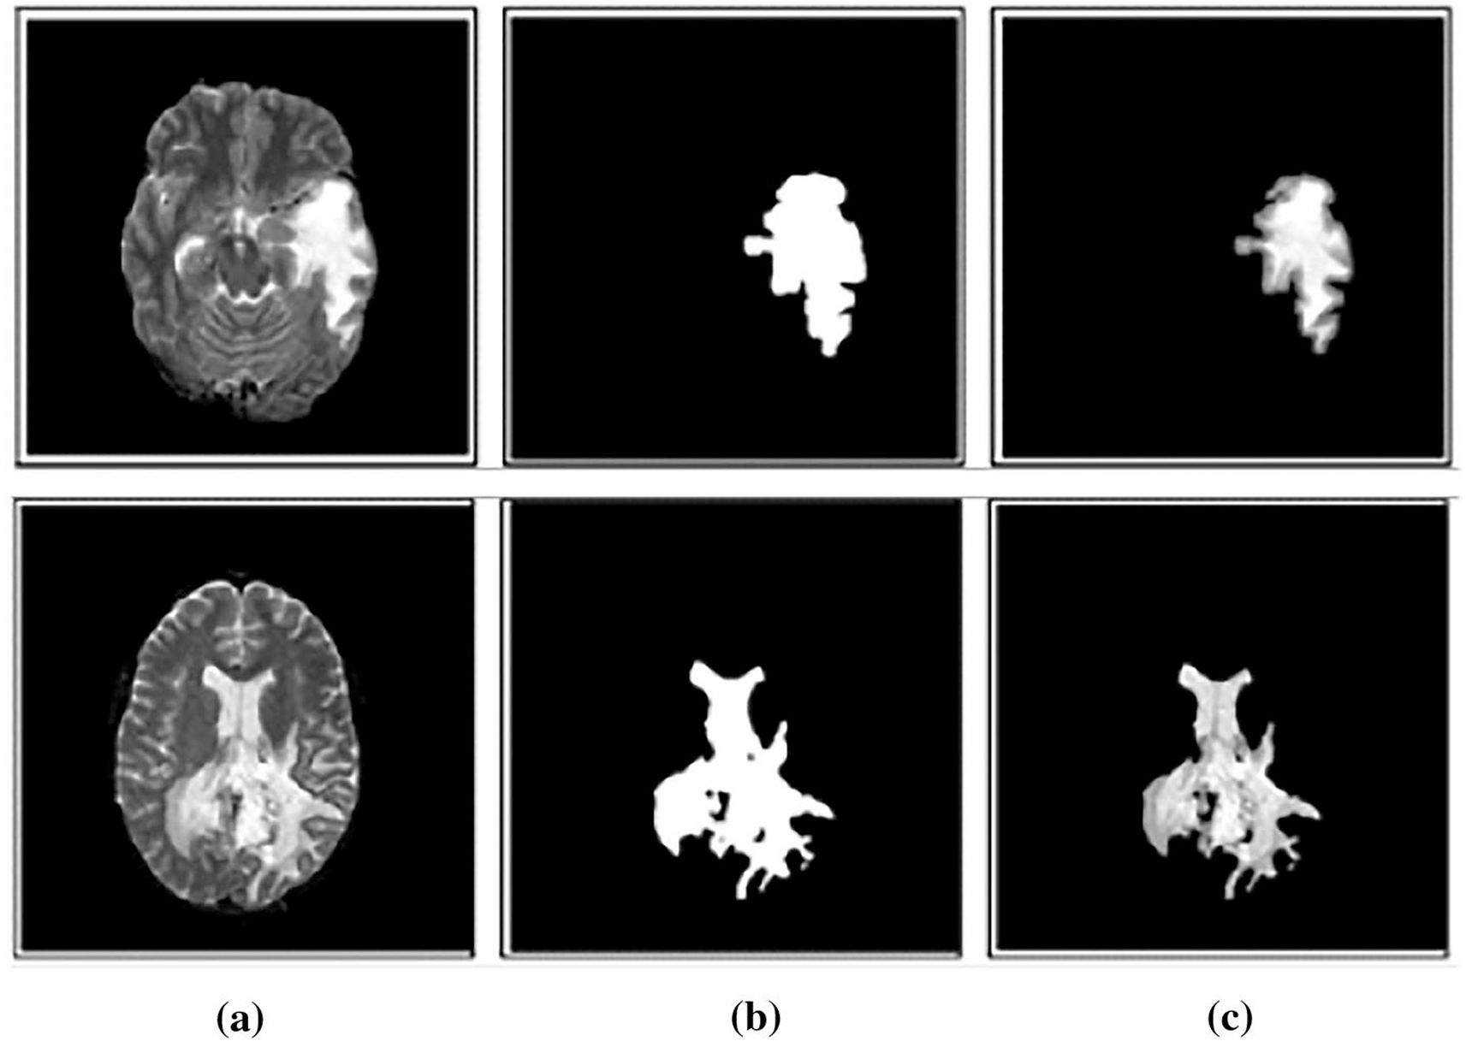

Figure 8-3: Results for segmentation (BRATS 2017 dataset) a preprocessed images, b CVS segmented, and c LSS segmented images

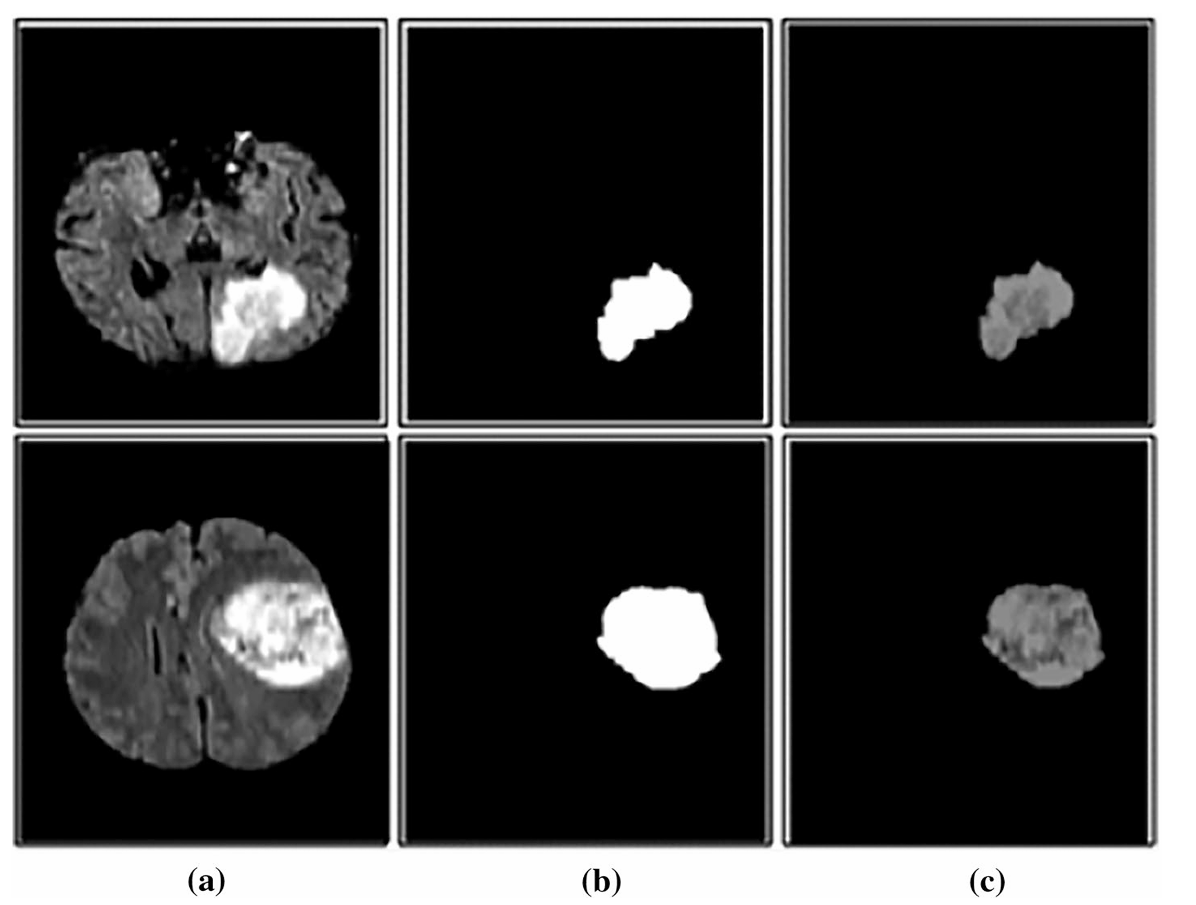

Figure 9-3: Results for segmentation (Harvard dataset a preprocessed image, b CVS segmented images, and c LSS segmented images

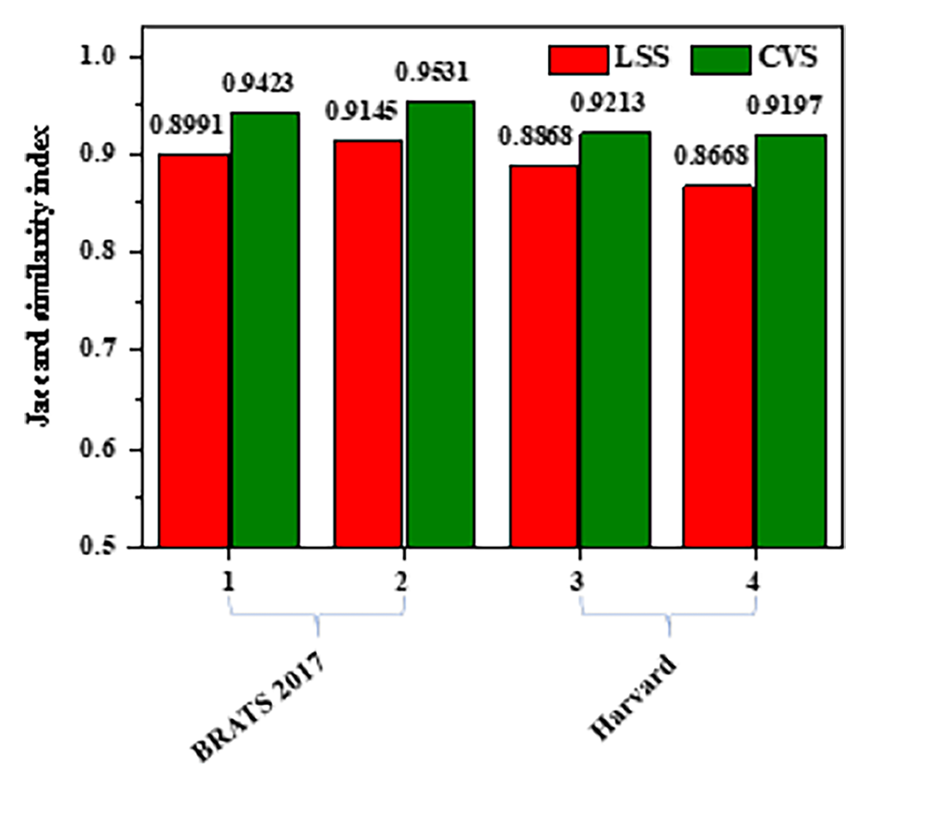

Figure 10-3: Comparison of JSI for LSS and CVS models in both datasets

Classification results

Next, using GLCM, the features are extracted. After tumor extraction from 300 MRI slices from T1w images, texture and shape features are extracted using GLCM method, eight dominant features are selected by t-test, and selected features and their statistical values ​​are selected. In this work, we focus on classifying the detected tumor, whether it is tumor or non-tumor. Therefore, subsequent classifications are applied based on the extracted features of tumor and non-tumor images. Data preparation: The performance of the classifier is based on the data considered during the training and testing task. In this work, out of 300 images, 210 images (70%) are considered for training, 90 images (30%) for validation for classification test. The classification results are validated on the BRATS 2017 dataset consisting of healthy and unhealthy images. All results were calculated using tenfold cross-validation.

Performance measures obtained with SVM and KNN for “σ=. When the number of selected features is 8 and σ=1.4, the performance of SVM classifier is superior. For lower and higher values ​​of the selected features, the accuracy obtained is lower. Therefore, the same number of selected features are given as input and the parameters are calculated. Therefore, in the framework of MLT, SVM with 8 dominant features and σ=1.4 has been trained and tested. Then the performance of SVM is compared with KNN. The values ​​of sensitivity, specificity and accuracy obtained with KNN are 84.69, 93.99 and 92.3%, respectively. The values ​​of sensitivity, specificity and accuracy obtained with SVM are 97.97, 97.09 and 98.98%, respectively. Comparison of the performance criteria of both SVM and KNN classifiers is presented in Figure 6. According to the literature review, the SVM classifier without active contour segmentation models provides only 96.48% classification accuracy for BRATS 2017 dataset. By comparing the performance criteria such as accuracy, sensitivity and specificity, it showed that the SVM classifier is better than the KNN classifier for classifying brain tumor images. The SVM technique classifies tumor or non-tumor with an accuracy improvement of 5.83% compared to KNN classification.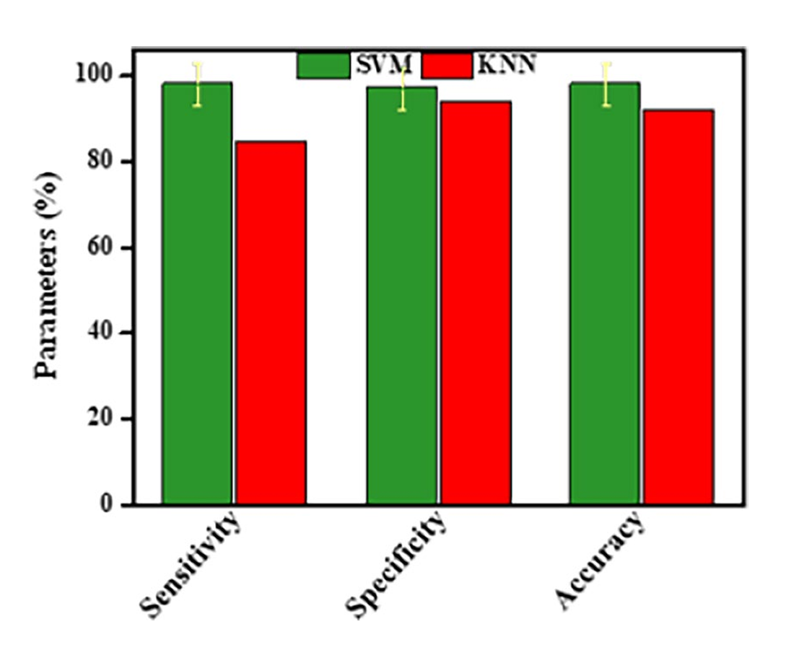

Figure 11 - 3. Comparison of SVM and KNN classifier performance metrics on BRATS 2017 dataset.

# Reference

An automated brain tumor detection and classifcation from MRI images using machine learning techniques with IoT

Anil Kumar Budati1  · Rajesh Babu Katta2 Received: 2 July 2021 / Accepted: 25 September 2021 / Published online: 12 October 2021 © The Author(s), under exclusive licence to Springer Nature B.V. 2021

automation of Brain Tumor Identification using EfficientNet on Magnetic Resonance Images Sushreeta Tripathya *, Rishabh Singhb and Mousim Rayc